Description

RtspProxy runs as a standalone RTSP server on a PC-compatible server as a reliable NT service to accept RTSP requests. It offers users a flexible extension opportunity with modules, a plugin-architecture. User will be able to customize the process for RTSP requests with applying various business application logic, or define own RTSP specification extensions.

Features

The TianShan RtspProxy service consists of the following features:
- Standalone RTSP server-side – a socket server with RTSP protocol support:
RTSP, RFC 2326
Up to 2000 concurrent connections
Client Session context management
Following verbs are supported:
OPTION, DESCRIBE, SETUP, PLAY, PAUSE, TEARDOWN, PING
Support of SSL on RTSP connection
- Multiple-session-access thru a single TCP connection
- One client session can be accessed thru different TCP connections
- Plugin framework – provide flexible customization opportunities
Business application logic map to plugin
Private business context
External application service support
- Implementation of TianShan Client Request Gateway (CRGw) for RTSP protocol – with the standard plugin ssm_TianShan_s1, the RtspProxy service can work as TIanShan CRGw to
support TianShan RTSP specification
support SeaChange ITV RTSP spec 2.0.3 for MoviceOnDemand application

Compatibility

- TianShan interface definitions 1.6
- Pure IP streaming network
- DVBC network
- VLC player (www.videolan.org/)
- RTSP spec of Sledgehammer (Axiom 4.0-)
- Compatible with SSL 1.0 and 2.0

Limitations

The RTSP bind interface will not be failover via Legato backup NICs

Running on Windows, the totally persistent and concurrent TCP connection will not exceed 10,000

Performance Characteristics

- RtspProxy Service can handle up to 10,000 concurrent connections. At this level, PtspProxy will use around 200MBytes of memory and 30% of one Xeon 2.4Ghz processor
- Regardless the latency introduced by the plugins, the RtspProxy service core will have 20 - 80 millisecond latency on message passing on a Xeon 2.4Ghz system.
- On a typical Xeon 2.4Ghz system, regardless the latency on non-TianShan components, with the ssm_TianShan_s1 module, the RtspProxy can process a stream setup in average 160 milliseconds with standard deviation 80 millisecond,
- process a stream control PLAY in average 100 milliseconds with standard deviation 66 millisecond,
- process a TEARDOWN in average 60 millisecond standard deviation 23 millisecond
- process a stream PAUSE in average 55 milliseconds with standard deviation 19 millisecond

Not Available in This Release

- Advertising server instances is not covered in this release.

Configuration

TianShan RtspProxy Service is distributed with ZQ TianShan Installation kit, it runs as an NT service on a Windows operating system. TCP/IP compatible network interface card is required on the system.
To work with other TianShan components, ssm_TianShan_s1 should be configured as its default plugin

Service Lifecycle Diagram

RtspProxy service work as an NT service, its lifecycle covers initialization, service loop and uninitlization as shown
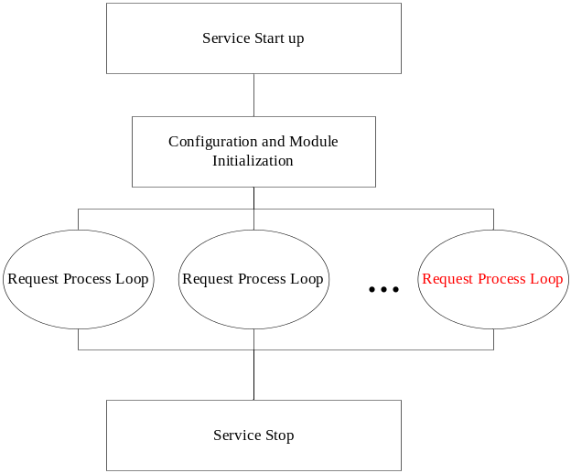

RTSP Request Process Loop

Every request come into the server will be processed by following the below loop:
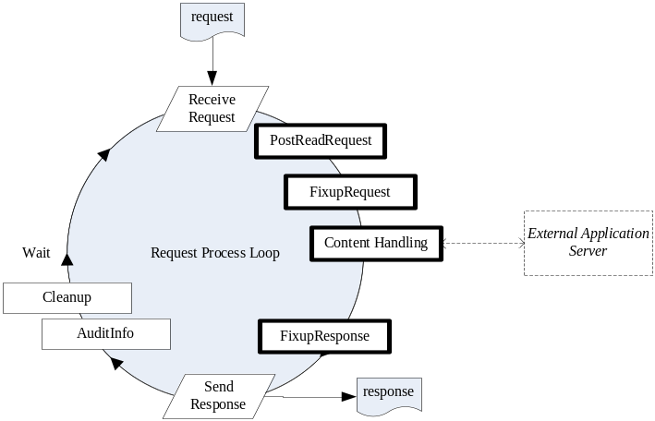
The bolded procedures are where a StreamSmith module, plugin, can hook and customize

SSM_TianShan_s1

The plugin ssm_TianShan_s1 will be shipped as the standard plugin with the kit. Ssm_TianShan_s1 supports TianShan RTSP specification 1.6, and has fixups to be compatible with SeaChange RTSP specification 2.0.3. It maps RTSP client sessions to TianShan server sessions and follows the definitions of a TianShan client request gateway.

Software and Hardware Requirements

PC Server | Version
Operating System | Windows 2000, 2003, XP
OpenSSL | Version 0.9.8a
TIanShan Environement | Version 1.6.x

If the service is running on Windows XP or any other non-server edition of Windows, the concurrent connection will be well reduced up to the OS limitation

